Asia-China-Coin-Spade-Hollow Handle-Pointed shoulder

Harthill, p. 14, 2.181

布币,Coin,Life Tool.It was created from the ancient farm tool.布币 was born in the early Spring and Autumn period and got to the top in the late warring states period.Mostly used in the Zhou nation and the Han,Zhao,Wei Vassal States.

甘丹空首布,The famous A"甘丹" Empty-head Spade-shape Coin in the Warring States Period."甘丹",also called"HanDan",Capital of Zhao Nation in the warring states Period.

This collection is a Huge Bronze Empty-head Spade-shape.Beautiful color with proper size.Well worth your collecting.

NAME:耸肩尖足空首布

SORT:Coin,Life Tool

MATERIAL:Bronze

LENGTH:13.5CM/5.31Inches

WIDTH:6.3CM/2.48Inches

CONDITION:Rust on the body,Museum quality

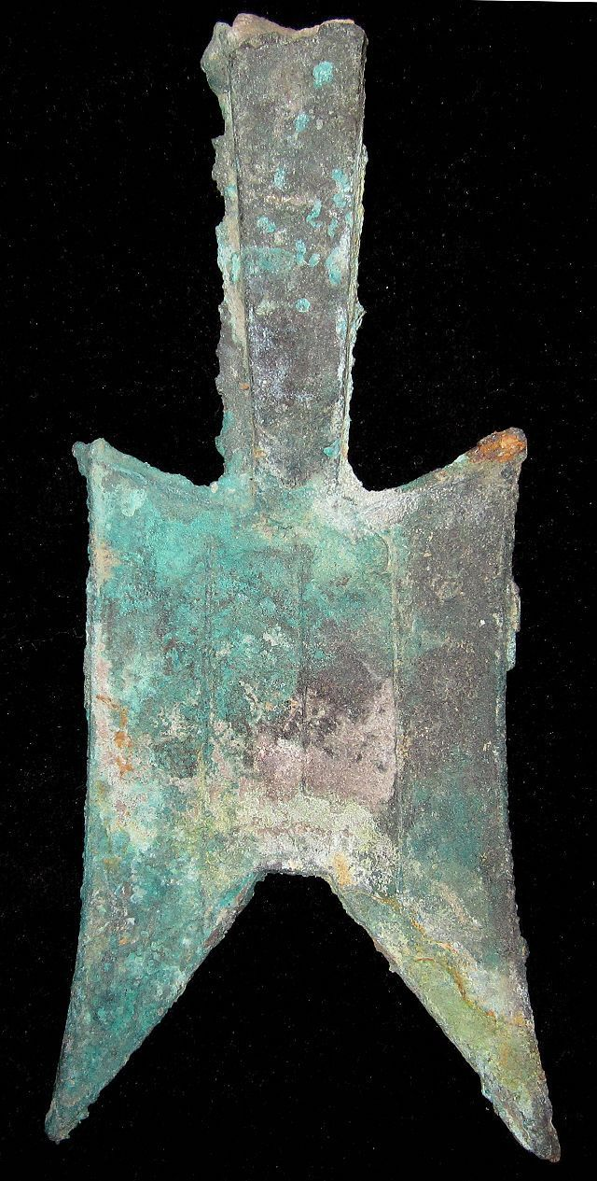 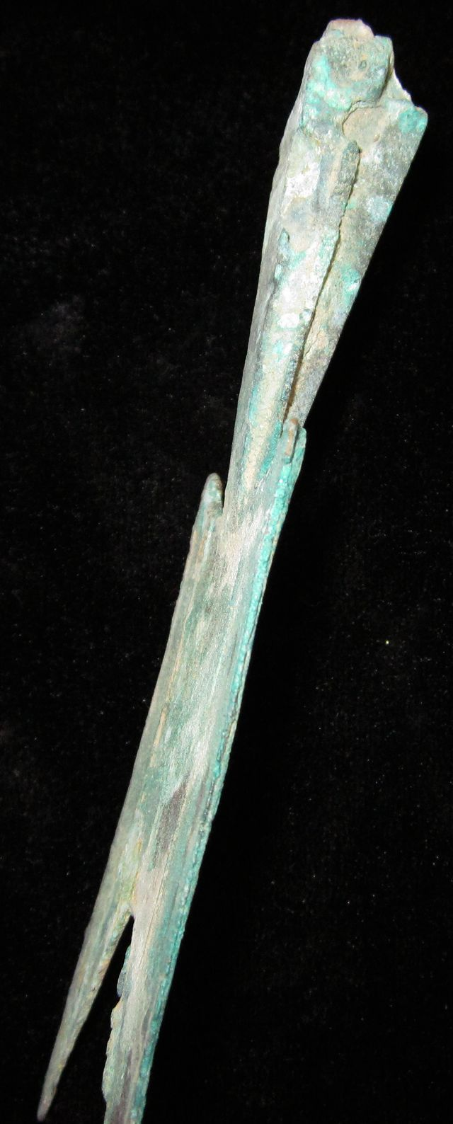

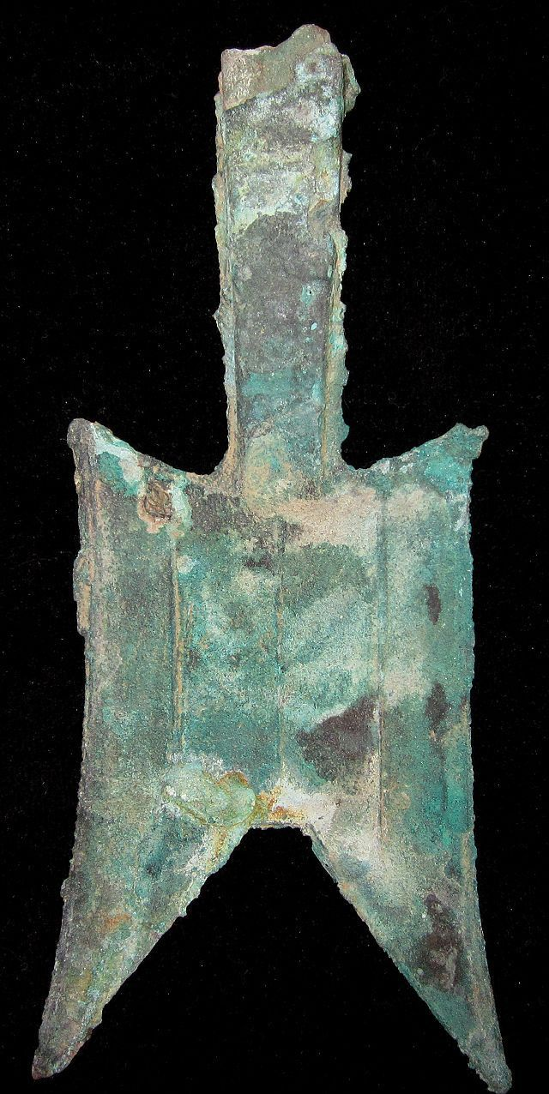

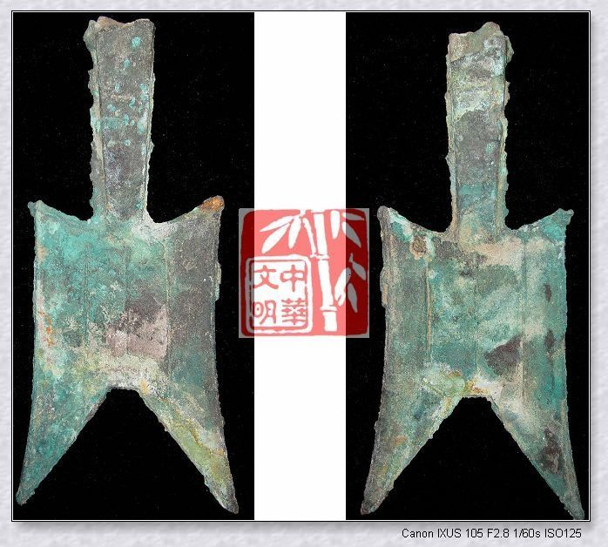

Order information

Order placed on Saturday, Dec 14, 2013

Payment method PayPal  
Payment date Saturday, Dec 14, 2013

Shipping address

Ralph J Coffman Jr

149 Atlantic Ave   
Swampscott MA 01907-2427  
United States

Phone number  
781 584 7091

Item(s) bought from cnrelics

#### Qty

#### Item name

#### Shipping service

#### Item price

1

SHANG ZHOU FISHER RIVER MAN MINT SEASHELL MONEY BRONZE GRIMACE ANTNOSE COIN秦字鬼脸钱 (151183182891)

Economy Shipping from outside US

$9.99

1

WARRING STATES PERIOD CHU NATION CITY MINT MONEY GOLD BRONZE ShellShape COIN金鬼脸钱 (151183833448)

Economy Shipping from outside US

$9.99

1

WarringStatesPeriod ZHAO NATION MINT SEAL LIN MONEY BRONZE ROUND COIN蔺圜钱1.5"RARE (151183844968)

Economy Shipping from outside US

$49.99

Item(s) bought from linzhoulin

#### Qty

#### Item name

#### Shipping service

#### Item price

1

CHINA "SHELL" Cash Coin 053130 (161171112357)

Economy Shipping from outside US

$9.90

Item(s) bought from bcculture

#### Qty

#### Item name

#### Shipping service

#### Item price

1

WarringStatesPeriod ZHAO NATION MINT FARMER CURRENCY MONEY BRONZE SPADE COIN空首布武 (251391165713)

Economy Shipping from outside US

$69.99

1

WarringStatesPeriod ZHAO KINGDOM CAPITAL MINT MONEY BRONZE SPADE COIN耸肩尖足空首布甘丹5" (251391439936)

Economy Shipping from outside US

$99.99

1

SpringAndAutumnPeriod CURRENCY MONEY BRONZE EMPTYHEAD SPADE SHAPE COIN禾大型平肩弧裆空首布 (251396315085)

Economy Shipping from outside US

$99.99

Order total

Subtotal

Shipping

Discount

Total

$349.84

$110.00

-$20.00

$459.84